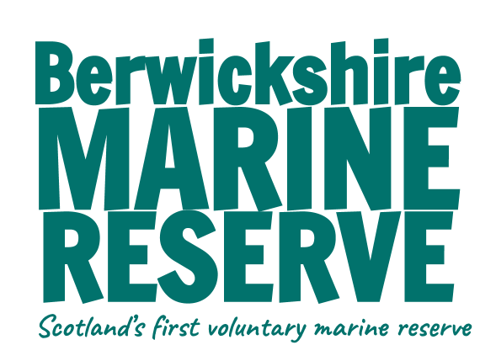 

**Part One - Plastic Planet and what I can do. Teacher notes.**

This section explores how plastic is linked to climate change by it’s production, and what alternatives there are, and what we can do to reduce the damage caused. Also covered is the damage done to the oceans by plastic in different ways.

Finally, it looks at what action can be taken and what we can all do to help.

**Power point** - as an introduction to this section start with the power point presentation. This can be followed by these activities:

**Plastic production**

For First Level / KS1

* Watch this [film on bbc bitesize](https://www.bbc.co.uk/bitesize/articles/zjpdr2p) and complete the quiz at the bottom of the webpage.

For Second Level / KS2

* [This BBC film](https://www.bbc.co.uk/programmes/p02gd1mr) explains the plastic production process in more detail - much more scientifically.
* Follow this with info sheet and worksheet

**Reduce, Reuse, Recycle**

For all levels

* [BBC Bitesize](https://www.bbc.co.uk/bitesize/articles/zpb3f82#z77ts82) write a poem about plastic activity
* Look through your home recycling - make a list on one day’s waste and think about how this could be avoided - what alternatives could you use? How could you reuse an item?
* Try to encourage more reduce, reuse and recycle behaviours in the school - what measures could you take. Who do you need to speak to to put this into action - parents / the class teacher / head teacher / local council? Campaign to get your ideas put into place. (eg: start a crisp packet recycling box, campaign to have single use plastic bottles banned in school, have a uniform recycling rail in the school, have a rehoming swap day for clothes, toys or books in the school)
* Make new items out of plastic waste eg: [plastic bottle bird feeder](https://www.nhm.ac.uk/discover/how-to-make-a-bird-feeder.html)
* Plastic free challenge - as a class challenge yourselves to make a plastic free meal (either at home or at school). How easy is it to buy the ingredients needed without any plastic packaging?

**Plastic in the Sea**

All levels

* [Lifespan of litter](https://uk.whales.org/wp-content/uploads/sites/6/2019/04/How-long-does-rubbish-take-to-break-down.pdf) activity from WDC
* Plastic facts - ask group to guess the statistic for each plastic fact. How does this make you feel? What can we do to change this?
* Make anti-litter posters
* Conduct a ‘the sea starts here’ campaign in your local area.

(see worksheets and this [group in Ullapool’s](https://ullapoolseasavers.com/what-we-do/campaigns/drain-campaign) efforts for inspiration.)

* Conduct a beach clean or litter pick - record your findings and submit the data to [Marine Conservation Society](https://www.mcsuk.org/what-you-can-do/join-a-beach-clean/).
* Do a nurdle hunt.

**Experiments**

1. Plastic - Journey to the Ocean
2. Make your own bioplastic